Chapter 11, Problem 41.

Obtain the power factor for each of the circuits in Fig. 11.68. Specify each power factor as leading or lagging.

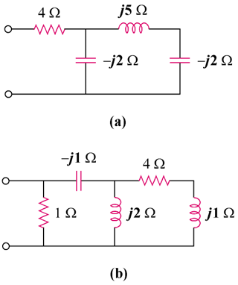

Figure 11.68
For Prob. 11.41.

